Why AoP Height doesn’t work

The AoP values one position go up and then back down. This means for one AoP value calculated there are two perturbations at which it can occur.

Figure 1 shows the AoP value (+/- 2%) for the predicted line on the graph has two regions which it can be.

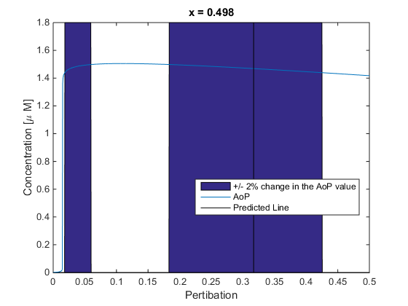

If we overlay this region with the height we are actually finding you will see that they intercept

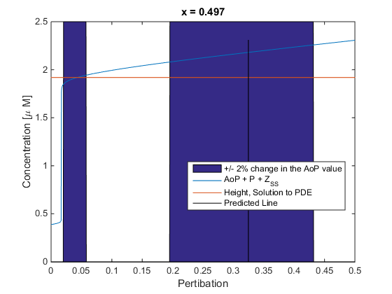

So what we need to do is translate the AoP value found for the actual height to the second value and it should give a more realistic AoP value.

New Predictions WRONG !!!!!!!

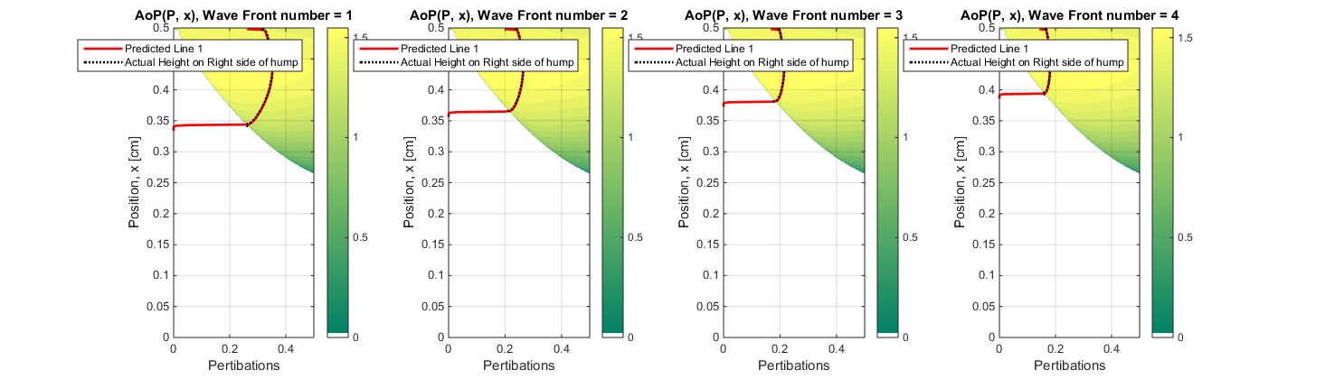^ The above is Wrong